# CS 255 System Design Document Template

This template lays out all the different sections that you need to complete for Project Two. Each section has guidance to prompt your thinking. You will need to continually reference the interview transcript as you work to make sure that you are addressing your client’s needs. There is no required length for the final document. Instead the goal is to complete each section based on what your client’s needs are. Remove this note when you are finished, and replace all bracketed text with the relevant information.

## UML Diagrams

### UML Use Case Diagram

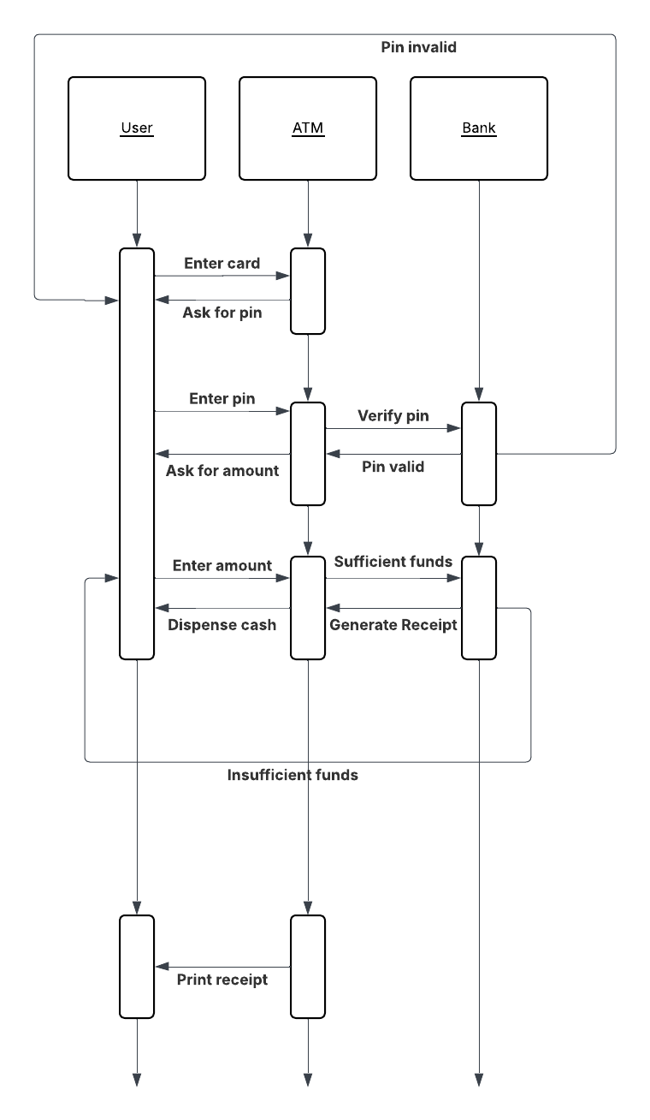

### UML Activity Diagrams

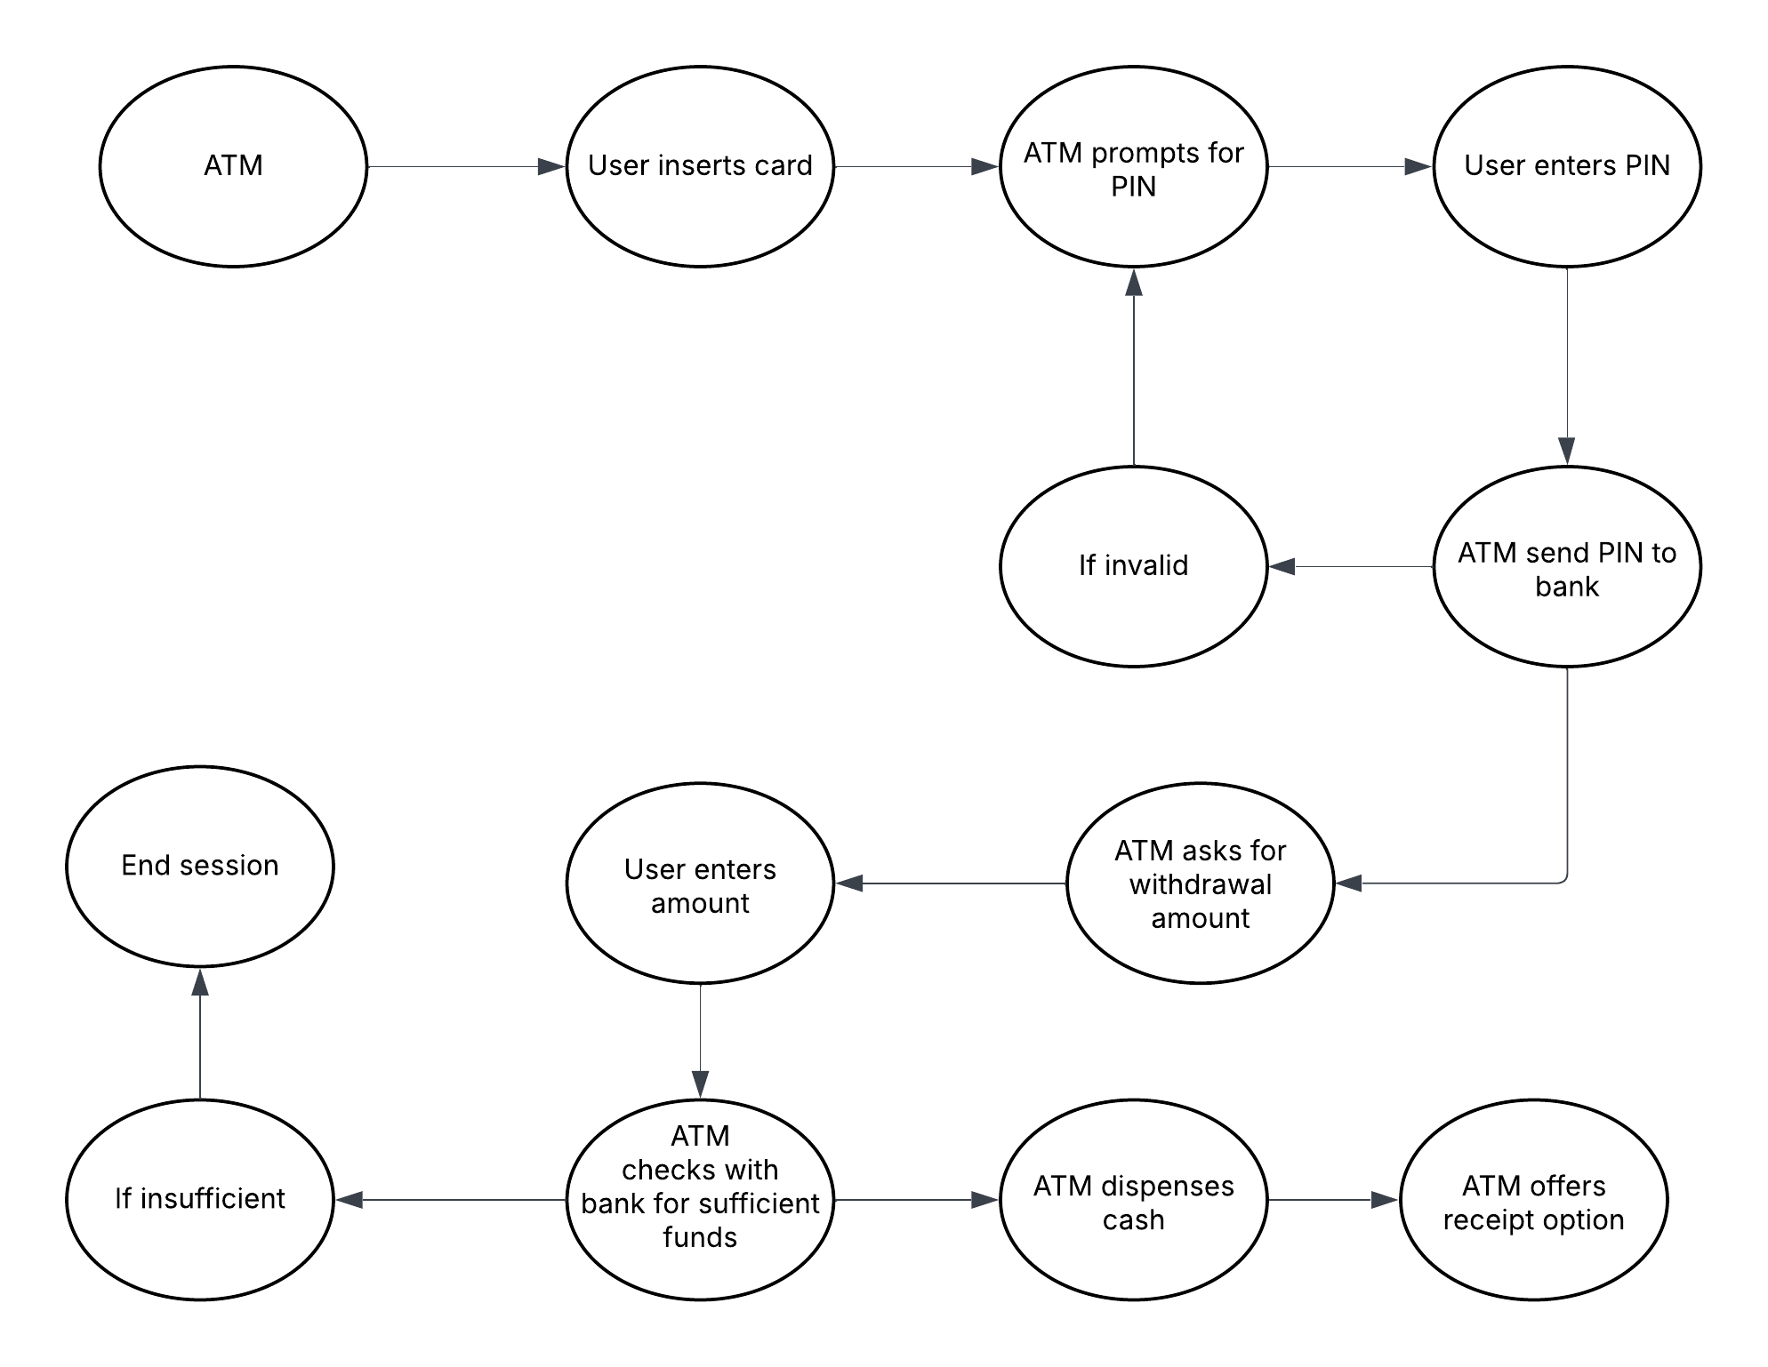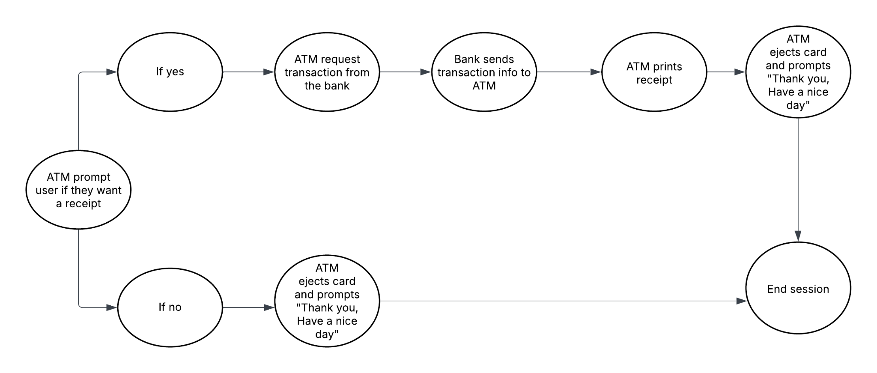

### UML Sequence Diagram

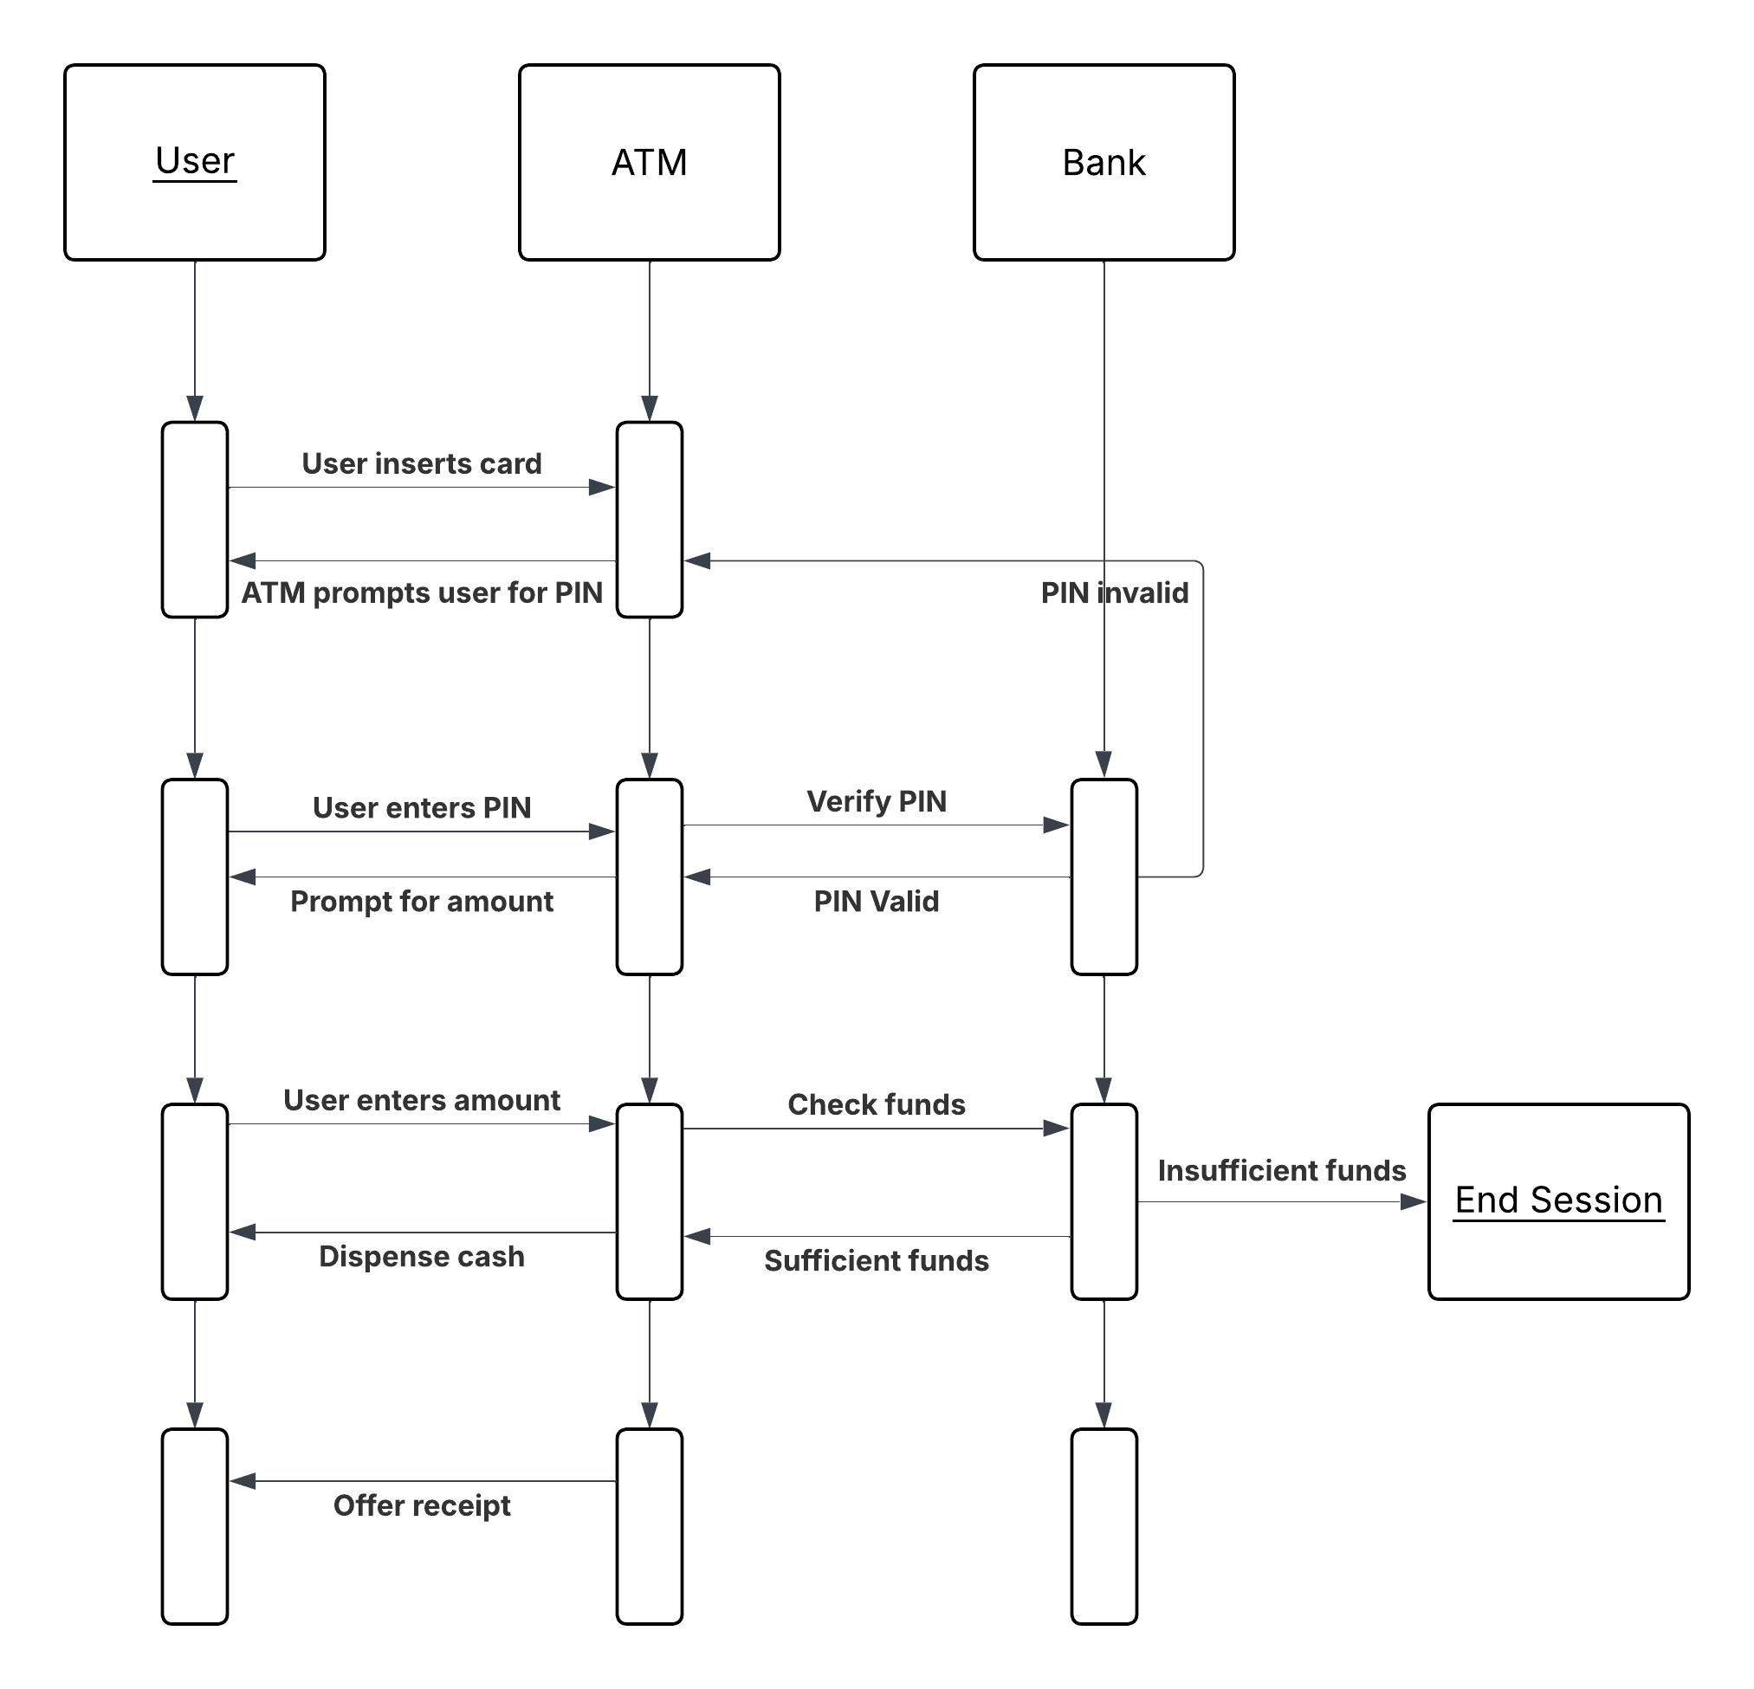

### UML Class Diagram

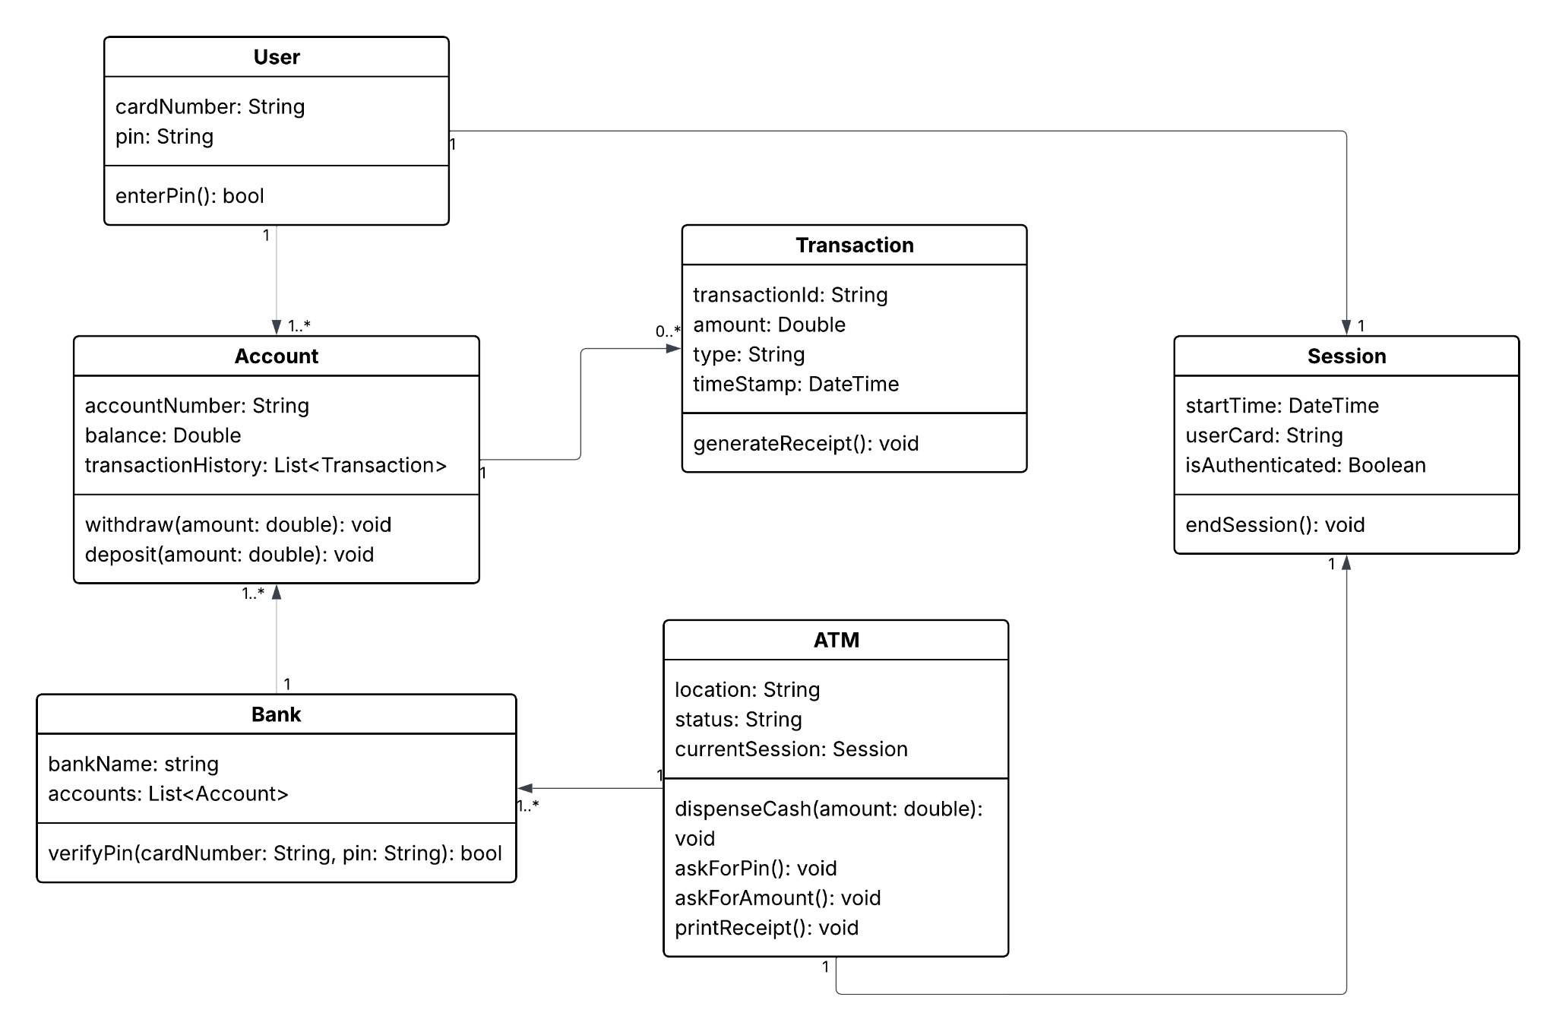

## Technical Requirements

*In order to have a functioning ATM system, a combination of hardware, software, tools, and supporting infrastructure are needed in order to function properly. On the hardware side, each ATM must have a card reader, PIN pad, cash dispenser, receipt printer, and display screen. Also a reliable server is needed to manage communications between the ATM and the bank’s backend systems. To ensure stable connectivity, network hardware such as routers, switches, and firewalls are necessary. The system also relies on specific software components such as including a secure ATM operating system like a custom Linux distribution. The ATM application software handles user interaction, transaction processing, and secure communication with the bank. On the bank’s side, backend software relies on PIN verification, checks account balances, and processes transaction requests, while a database such as MySQL stores account details and transaction history.*

*Software is built and maintained using development tools like IDEs such as Visual Studio, and system architecture modeling is aided by design tools like Lucidchart. Security tools and encryption libraries are critical to protect sensitive data and ensure a secure and safe communication between the ATM and the bank. The infrastructure must include a secure network like a VPN or a dedicated private connection to protect data in transit. Depending on the bank’s deployment strategy, backend systems can be hosted on cloud platforms such as AWS or maintained through on premise servers. Lastly, a fail-safe disaster recovery plan, data backups,and real time monitoring tools are necessary to maintain system reliability and quickly respond to any issues or security threats.*